PROJECT REPORT

On

“GYM schedule Reminder”

Submitted in the partial fulfilment of Masters of Computer Applications

To

Uttaranchal University

Uttaranchal School of Computing Sciences

SESSION- 2024-2025

**Under the Supervision of Submitted by**:

Mr. Abhinav Kumar Minakshi Kumari

(Assistant Professor) Enroll no.: UU2320000063

USCS MCA . II sem. Sec A

**ACKNOWLEDGMENT**

The most awaited moment of any is successful completion, but nothing can be done successfully if done alone. Success is the outcome of contribution and consistent help of various person and we thank those ones who helped us in successful completion of this project.

Primarily would like to thank **Prof (Dr.) Sonal Sharma, Director-USCS** for providing a healthy and encouraging environment to study.

I profusely thankful to **Dr. Sameer Dev Sharma, Head of Department-USCS** for their valuable support and guidance to build the project.

I am also thankful to **Program Coordinator- MCA 2st Year, Assistant Professor-USCS** for providing all the required resources in the successful completion of my project report.

I express my thanks to**, Mr.Abhinav, Assistant Professor-USCS.** He has been generous enough to provide me an opportunity ad accepting my project for the most valuable guidance and affordable treatment given to us at every stage to boost my morale

Roll No: 49

M.C.A 3nd Semester

Section -A

**DECLARATION**

I hereby declared that the project report entitled **“**GYM schedule Reminder**”** submitted by **Minakshi kumari** to Uttaranchal School of Computing Science. The project report was done under the guidance of **Mr. Abhinav, Assistance Professor-USCS.** I further declare that the work reported in this project report has not been submitted and will not be submitted, either in part or in full, for the award of any other degree or diploma in this university or any other university or institute.

Roll No: 49

MCA 3 ndSemester

Section: A

**CERTIFICATE**

This is certify that **Minakshi kumari** of MCA 3nd Semester, of **“Uttaranchal School of computing science, Dehradun”,** has completed the project Report for the **topic** **“**GYM schedule Reminder**”** for the session (2024- 2025).

**Under the guidance of:**

Mentor Name:

Mr.Abhinav

Assistant professor

USCS Uttaranchal University

**TABLE OF CONTENTS**

|  |  |  |
| --- | --- | --- |
| **S.NO.** | **CONTENT** | **PAGE NO.** |
|  | **Acknowledgement** | **Ⅰ** |
|  | **Declaration** | **Ⅱ** |
|  | **Certificate** | **Ⅲ** |
| **1.** | **Introduction**   * 1. Objective of the project   1.2 future Scope of the project | **1-3** |
| **2.** | **System Analysis/Requirement**  2.1 Identification of need  2.2 Preliminary Investigation  2.3 Feasibility Study  2.4 Project Planning And Model used  2.5 Project Scheduling (PERT Chart and GANTT chart)  2.8 Data models: DFD  2.9 UML  3.0 Flow chart | **4-14** |
| **3.** | **System Design**  3.1 Modularisation details | **15** |
| **4.** | **Testing**  4.1 Testing techniques and testing strategies used  4.2 System Security measures  4.3Reports | **17-18** |
| **5.** | **Conclusion**  5.1 Limitation of the project | **19** |
| **6.** | **Appendices**  6.1 Coding | **21-83** |
| **7.** | **Bibliography** | **84** |

**INTRODUCTION**

**Welcome to a New Era of Fitness Management**

In today’s fast-paced world, juggling work, family, and personal time can often leave little room for fitness. Many individuals start their fitness journey with enthusiasm but struggle to maintain a consistent routine. The solution? A dedicated platform that not only helps you schedule your workouts but also keeps you motivated along the way. Welcome to our Gym Schedule Reminder Website—your ultimate fitness companion!

**The Importance of Consistency in Fitness**

Consistency is key when it comes to achieving fitness goals. Whether you're aiming to lose weight, build muscle, or simply lead a healthier lifestyle, establishing a regular workout routine is crucial. However, many find it difficult to prioritize their fitness amidst daily responsibilities. Our website is designed to bridge that gap, providing you with tools and support to stay committed to your health journey.

**Key Features of Our Platform**

1. **Customizable Workout Schedules**
   * Tailor your workout plan to fit your unique lifestyle. Whether you prefer morning workouts or late-night sessions, our platform allows you to create a schedule that works for you. Input your preferred workout times, types of exercises, and any rest days you need.
2. **Timely Reminders and Notifications**
   * Receive reminders via email or SMS to ensure you never miss a workout. Customize how often and when you want these notifications to come, whether it’s an hour before your session or a daily recap of your planned workouts.
3. **Progress Tracking and Analytics**
   * Monitor your progress with our easy-to-use tracking tools. Log your workouts, track your achievements, and visualize your progress over time. Celebrate milestones and stay motivated by seeing how far you’ve come.
4. **Flexible Rescheduling Options**
   * Life can be unpredictable, and sometimes your best-laid plans need adjusting. Easily reschedule workouts with just a few clicks, ensuring your fitness routine adapts to your lifestyle.
5. **Community Support and Resources**
   * Join a community of like-minded fitness enthusiasts. Share tips, motivate each other, and even find workout buddies. Access a library of resources, including workout ideas, nutrition tips, and wellness articles.

**Why Choose Our Gym Schedule Reminder Website?**

1. **Stay Accountable**
   * Accountability is a crucial element in sticking to any fitness regimen. By having scheduled reminders, you’re more likely to follow through with your workouts. Our platform provides that extra nudge to keep you on track.
2. **Boost Your Motivation**
   * Tracking your progress is essential for motivation. Our analytics tools allow you to see improvements in your strength, endurance, and overall fitness levels, encouraging you to push harder and achieve your goals.
3. **Cultivate Healthy Habits**
   * Establishing a routine is vital for long-term success in fitness. Our platform helps you develop healthy habits by making scheduling workouts easy and hassle-free.
4. **User-Friendly Interface**
   * Our website is designed with you in mind. Enjoy a seamless experience whether you’re on a computer, tablet, or mobile device. The intuitive interface makes it easy to navigate, schedule, and track your workouts.
5. **Accessible for Everyone**
   * Whether you’re a fitness beginner or a seasoned athlete, our platform caters to all levels. With customizable options, you can set a schedule that aligns perfectly with your fitness journey.

**Getting Started**

Ready to take control of your fitness journey? Signing up for our Gym Schedule Reminder Website is quick and easy. Just create an account, customize your workout schedule, and start receiving reminders. Join our community and embark on a transformative path toward a healthier lifestyle today!

This introduction can serve as a solid foundation. To expand it to 2000 words, consider adding sections on:

* **Personal Success Stories:** Highlight testimonials from users who have successfully transformed their fitness routines using the website.
* **Detailed Features Breakdown:** Dive deeper into each feature, explaining how they work and their benefits.
* **Expert Tips on Staying Motivated:** Provide practical advice and strategies from fitness experts on maintaining motivation and consistency.
* **FAQs:** Address common questions users might have about the platform.
* **Future Developments:** Discuss potential future features and improvements based on user feedback.

**OBJECTIVES**

**1.Promote Consistency in Workouts:**

Help users establish and maintain a regular workout routine, making fitness a consistent part of their lives.

**2.Enhance Accountability:**

Provide reminders and notifications to encourage users to stay committed to their scheduled workouts, fostering a sense of responsibility.

**3.Facilitate Goal Achievement:**

Support users in setting and achieving their fitness goals by providing tools for tracking progress and celebrating milestones.

**4.Offer Customization and Flexibility:**

Allow users to create personalized workout schedules that fit their unique lifestyles, preferences, and fitness levels.

**5.Encourage Community Engagement:**

Build a supportive community where users can share experiences, tips, and motivation, fostering a sense of belonging.

**6.Provide Educational Resources:**

Offer access to valuable fitness resources, including workout ideas, nutrition tips, and wellness information to enhance users’ knowledge and commitment.

**7.Improve User Experience:**

Ensure a user-friendly interface that makes scheduling, tracking, and adjusting workouts simple and enjoyable.

**8.Increase Motivation:**

Utilize progress tracking and analytics to inspire users by visualizing their achievements and encouraging them to push toward their goals.

**9.Support Mental Well-being:**

Promote the mental health benefits of regular exercise, helping users manage stress and enhance overall well-being through fitness.

**10.Adapt to User Needs:**

Continuously improve the platform based on user feedback to better serve the community and address evolving fitness needs.

These objectives aim to create a comprehensive platform that empowers individuals to take charge of their fitness journeys and achieve lasting results.

**FUTURE SCOPE**

**1.Integration with Wearable Devices:**

Collaborate with fitness trackers and smartwatches to sync workout data, providing real-time feedback and enhancing user engagement.

**2.Personalized Workout Plans:**

Offer AI-driven customized workout programs based on user preferences, fitness levels, and progress, adapting over time to keep users challenged.

**3.Nutrition Tracking and Meal Planning:**

Incorporate features for tracking nutrition and providing meal plans tailored to individual fitness goals, promoting a holistic approach to health.

**4.Virtual Training Sessions:**

Introduce options for virtual personal training or group classes, allowing users to work out with trainers or peers from home.

**5.Gamification Elements:**

Implement gamification strategies such as challenges, badges, and rewards to enhance motivation and make fitness more engaging.

**6.Community Forums and Events:**

Develop a platform for users to connect, share experiences, participate in challenges, and attend fitness events, fostering a sense of community.

**7.Mental Health and Wellness Resources:**

Provide access to content focused on mental well-being, including stress management techniques, mindfulness exercises, and wellness articles.

**8.Multilingual Support:**

Expand the platform’s accessibility by offering multilingual support to cater to a broader audience globally.

**9.Mobile App Development:**

Launch a dedicated mobile app to enhance user accessibility and convenience, ensuring users can manage their schedules on-the-go.

**10.Integration with Virtual Gym Memberships:**

Partner with gyms and fitness centers to allow users to book classes or sessions directly through the platform, streamlining the fitness experience.

**11.Feedback and Improvement Mechanisms:**

Establish channels for user feedback to continually enhance features, ensuring the platform evolves in line with user needs and trends.

**12.Collaborations with Fitness Influencers:**

Work with fitness influencers and professionals to provide exclusive content, tips, and challenges, enriching the user experience.

**13.Sustainability and Eco-Friendly Initiatives:**

Introduce features that promote sustainable fitness practices, such as eco-friendly workout gear recommendations or challenges to reduce carbon footprints.

By embracing these opportunities for growth and innovation, the Gym Reminder Website can evolve into a comprehensive fitness ecosystem that meets diverse user needs and fosters a thriving community.

**SYSTEM ANALYSIS**

The system analysis of a subject information proving system in HTML,CSS ,JAVASCRIPT and web REAL TIME COMMUNICATION environment involves a comprehensive evaluation of various components to ensure the project's success. Based on the provided sources, here are key points to consider for the system analysis:

* **Program Information Database:** Utilize a program information database to extract valuable information from source codes, facilitating program analysis and understanding. This database can be used to support research in program comprehension, reverse engineering, and component extraction.
* **Integration with Existing Tools:** Ensure seamless integration with existing tools and technologies to enhance the analysis capabilities of the system. Consider the use of static analysis like which can detect errors and vulnerabilities in programs.
* **User Control and Expressiveness:** Empower developers to express functional and non-functional requirements within the program itself. Allow developers to specify guarantees about their programs directly, leveraging their domain knowledge and project-specific requirements for better assurance.

**IDENTIFICATION OF NEED**

The identification of need for a subject information proving system in involves recognizing the challenges and complexities associated with analysis programs. Based on the provided sources, here are key points related to this identification:

* **Complexity of vs code Programs:** here programs are known for their complexity, making it challenging to analysis them effectively. The language's semantics, including multiple inheritance, templates, object layout, construction, and destruction, contribute to the difficulty of reasoning about real-world programs.
* **Lack of Standardization:** The lack of a universally accepted standard for programs poses a significant challenge. Existing resources are often incomplete, outdated, and too complex to understand easily, requiring significant expert knowledge to navigate through the language's intricacies.
* **Developer Control and Expressiveness:** There is a need for developers to have direct control over additional guarantees about their programs. Developers are best positioned to express functional requirements, constraints, and limitations specific to their projects. Providing developers with simple building blocks to compose precise and scalable static analyses within the language itself can enhance program assurance.
* **Simplifying Analysis:** Simplifying the analysis of programs is crucial. By hiding the complexity of the language's semantics from users through proper abstractions, ensuring guarantees about a program can be made more accessible and efficient. This approach aims to make analysis programs as straightforward as writing the programs.

**PRELIMINARY INVESTIGATION**

* A preliminary investigation report is a document that collects evidence, identification and information about what the incident is about and the people or person involved during this problem. In addition to that, it is a type of report that is simply a record without a full idea of what was going on.
* **Basics:** The concept of types in early programming languages simplifies data interpretation. Variables must be declared before use in , and their type cannot be changed during program execution. Constants are non-modifiable variables declared with the keyword 'constant' and must be initialized during declaration.
* **Complexity of Programs:** programs are complex due to language semantics like multiple inheritance, templates, and object layout. Analysis C++ programs requires expert knowledge and tools like reverse engineering, and object-oriented design recovery.
* **Information Database:** Program information extracted from source codes is valuable for software engineering research. Tools like a program information database to store and retrieve essential information needed for analysis tools facilitating program understanding and restructuring existing software.

**FEASIBLITY STUDY**

The feasibility study of a subject information proving system involves assessing various factors to determine the viability of the project. This study is crucial in the planning phase of the system development life cycle. Its check the what resources we required before our projects execution Some key aspects that need to be evaluated include economic feasibility, technical feasibility, operational feasibility, scheduling feasibility.

* **Economic Feasibility:** Involves conducting a cost-benefit analysis and using financial techniques like time value of money to assess the economic viability of the project.
* **Technical Feasibility:** Focuses on evaluating whether the technical resources and capabilities are sufficient to execute the project successfully.
* **Operational Feasibility:** Analysis how well the project meets the organization's operational needs and requirements.
* **Scheduling Feasibility:** Determines the time required for project completion, which is crucial for project success.

**PROJECT PLANNING**

The project planning for a subject information providing system in C++ involves several key stages to ensure its successful development. Here is an outline of the project planning process based on the information provided in the search results:

* **Define Project Objectives:** Clearly outline the goals and objectives of the subject information providing system.
* **Feasibility Study:** Conduct a feasibility study to assess the practicality and viability of the project. Evaluate technical, economic, and operational aspects to determine the project's feasibility.
* **System Analysis and Design:** Analysis the requirements of the subject information providing system. Design the system architecture, database structure, and user interactions based on the identified needs.
* **Development and Implementation:** Begin the development phase of the project, where the system is built according to the design specifications. Implement features, functionalities, and data management components using C++.
* **Testing and Quality Assurance:** Conduct thorough testing to ensure the system functions as intended. Perform unit testing, integration testing, and user acceptance testing to identify and resolve any issues.
* **Documentation:** Document the project thoroughly, including system requirements, design documents, user manuals, and technical specifications. Maintain detailed records of the development process for future reference.
* **Maintenance and Updates:** Plan for ongoing maintenance and updates to the system. Establish procedures for handling bug fixes, implementing new features, and ensuring the system remains up-to-date.

**MODEL USED**

**WATERFALL MODEL**

* *The waterfall model is a*[*software development model*](https://www.geeksforgeeks.org/top-8-software-development-models-used-in-industry/)*used in the context of large, complex projects, typically in the field of information technology.*
* *It is characterized by a structured, sequential approach to*[*project management*](https://www.geeksforgeeks.org/software-engineering-software-project-management-plan-spmp/)*and*[*software development*](https://www.geeksforgeeks.org/software-development/)*.*

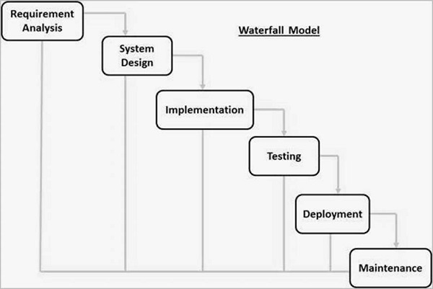

**PROJECT SCHEDULING**

* **GANTT CHART**
* A gantt chart is a horizontal bar chart used in project management to visually represent a project plan over time.
* A Gantt chart is a popular tool for showing activities (tasks or events) against time in project management.

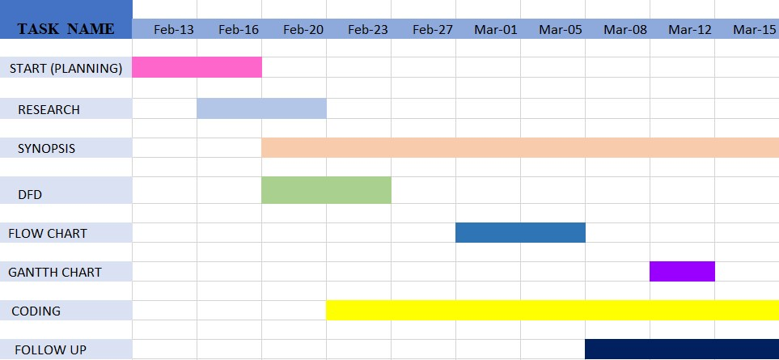

* **PERT CHART**
* A PERT chart, also known as a PERT diagram, is a tool used to schedule, organize, and map out tasks within a project.
* PERT stands for program evaluation and review technique.
* It provides a visual representation of a project's timeline and breaks down individual tasks. These charts are similar to Gantt charts, but structured differently.

**TASK 6:**

Duration 5 days

**TASK 1:**

Duration 4 days

**FINISH**

**TASK 5:**

Duration 4 days

**TASK 4:**

Duration 3 days

**TASK 2:**

Duration 6 days

**TASK 3:**

Duration 2 days

**START**

**USE -CASE DIAGRAM**

A use case diagram is a graphical depiction of a user's possible interactions with a system.

**USER 1**

**USER 2**

**FLOW CHART**

A flowchart is a type of diagram that represents a workflow or process.

The flowchart shows the steps as boxes of various kinds, and their order by connecting the boxes with arrows.

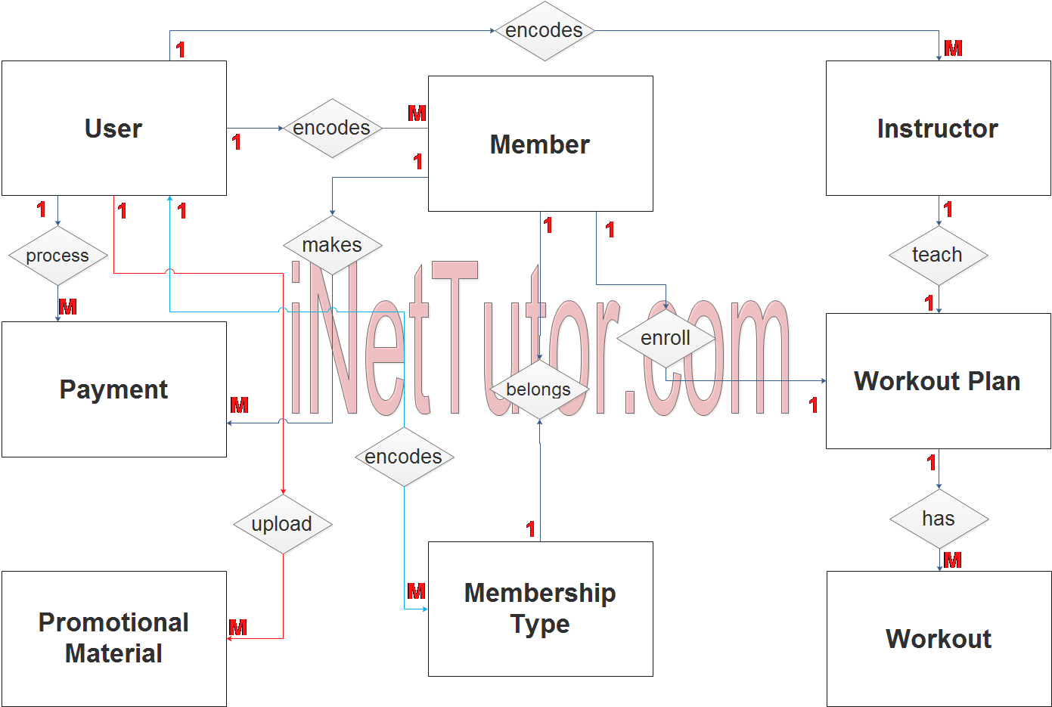

**SYSTEM DESIGN**

* **MODULARISATION DETAILS**
* **Identify the functionalities of the system:** The first step is to identify the functionalities of the system and group them into logical modules. For example, a module for data management, a module for user interfaces, and a module for business logic.
* **Define the interfaces of the modules:** Each module should have a well-defined interface that specifies the inputs and outputs of the module. The interface should be designed using abstraction and encapsulation principles to hide the implementation details of the module.
* **Implement the modules:** Each module can be implemented as a class or a set of related functions. The implementation should follow the principles of modular programming, such as encapsulation, abstraction, and separation of concerns.
* **Test the modules:** Each module should be tested independently to ensure that it meets its functional and non-functional requirements.
* **Integrate the modules:** Once the modules are tested, they can be integrated into a cohesive system. The integration should be done using the interfaces of the modules to ensure that the system is loosely coupled and easily maintainable.

**SYSTEM AND INTEGRATION TESTING**

* **SYSTEM TESTING:**
* **Functional Testing:** Test each function/module of the system to ensure that it performs as expected.

Examples:

* Test adding a new subject to the system.
* Test updating subject information.
* **User Interface Testing:** Verify that the user interface elements work correctly.

Examples:

* Test user login/logout functionality.
* Test navigation through the system.
* **Performance Testing:** Measure the system's responsiveness and stability under various load conditions.

Examples:

* Test the system's response time when handling multiple concurrent requests.
* **Security Testing:** Verify that the system is secure against common security threats.

Examples:

* Test authentication mechanisms.
* Test authorization controls.

**INTEGRATION TESTING:**

* **Module Integration Testing:** Test the interactions between different modules/components.

Examples:

* Test the integration between the user interface and the backend system.
* Test the integration between the database and the data access layer.
* **Data Integration Testing:** Test the flow of data between different parts of the system.

Examples:

* Test data retrieval from the database and its display on the user interface.
* Test data updates and validations.
* **Interface Testing:** Test the interfaces between different modules/components for proper data exchange.

Examples:

* Test API calls between frontend and backend components.
* Test file I/O operations.
* **Dependency Testing:** Identify and test dependencies between modules/components.

Examples:

* Test how changes in one module/component affect others.
* Test error handling and exception propagation.

**SYSTEM SECURITY MEASURES**

* **Data Encryption:**
* Encrypt sensitive data, such as subject information, stored in databases or files to prevent unauthorized access.
* Use industry-standard encryption algorithms (e.g., AES, RSA) and secure key management practices.
* Implement end-to-end encryption for data transmission over networks to protect data in transit.
* **Secure Communication:**
* Use secure communication protocols, such as HTTPS, TLS/SSL, for client-server communication to prevent eavesdropping and man-in-the-middle attacks.
* Implement certificate-based authentication to verify the identity of servers and clients.
* **Data Validation:**
* Validate and sanitize all user inputs to prevent malicious input that could lead to vulnerabilities, such as buffer overflows, format string attacks, or code injection.

**LIMITATION OF WEB RTC**

**1. Dependence on User Input:**

* Users must consistently input their schedules and update changes, which can lead to inaccuracies if they forget or neglect to do so.

**2.Limited Personalization:**

* While customization options exist, they may not fully account for individual preferences, fitness levels, or specific goals without more advanced AI integration.

**3.Motivation Variability:**

* The effectiveness of reminders and notifications can vary by individual; some may respond positively, while others may ignore them over time.

**4. Technical Issues:**

* Users may encounter bugs, glitches, or downtime, affecting their ability to access schedules and reminders when needed.

**5. Lack of Real-Time Support:**

* The platform may not provide immediate assistance or feedback during workouts, which can be crucial for beginners or those needing guidance.

**6. Overwhelm from Information:**

* Users might feel overwhelmed by too many features or options, leading to confusion rather than improved organization and motivation.

**7. Privacy Concerns:**

* Users may have concerns about sharing personal fitness data, especially if the platform requires sensitive information for tracking.

**8. Static Features:**

* If the platform doesn’t evolve with user feedback, it may become outdated or less useful, failing to meet the changing needs of users.

**9. Accessibility Issues:**

* Users without reliable internet access or those who are not tech-savvy may struggle to utilize the website effectively.

**10.Integration Challenges:**

* Compatibility issues with other fitness apps or devices may limit the seamless experience users expect.

**11. Potential for Misuse:**

* Users might rely solely on the platform for accountability, neglecting to develop motivation and self-discipline.

**12.Community Dynamics:**

* If a community feature is implemented, managing interactions could be challenging, leading to potential negativity or unsupportive behaviors.

**CODING**

**BIBLIOGRAPHY**

For successfully completing my project file .

I have taken help from the following website links:-

* [WWW.GOOGLE.COM](http://WWW.GOOGLE.COM)
* [WWW.WIKIPEDIA.COM](http://WWW.WIKIPEDIA.COM)
* <https://medium.com/@fengliu_367/getting-started-with-webrtc-a-practical-guide-with-example-code-b0f60efdd0a7>
* [WWW.TUTORIALPOINT.COM](http://WWW.TUTORIALPOINT.COM)